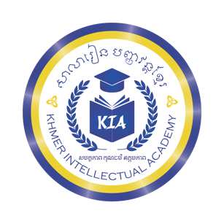
សាលារៀន បញ្ញវន្តខ្មែរ

Khmer Intellectual Academy
សមត្ថភាព គុណធម៌ ឧត្តមភាព

Full-time Teachers (New Academic Year 2026-2027)
No | Current Classes |  |  | New Classes for
 | Teacher's Name | Level | Sts | Teacher's Name | Level | Students
1 | Vannak Sreyneath | K1 | 20 | Vannak Sreyneath | K1 | 0
2 | Lorn Sopheak | K2A | 49 | Lorn Sopheak | K2A | 10 (Neath)
3 | Chorm Yaphai | K2B | 54 | Chorm Yaphai | K2B | 10 (Neath)
4 | Yin Thary | K3A | 46 | Yin Thary | K3A | 54 (Yaphai)
5 | Beun Sreyleak | K3B | 51 | Beun Sreyleak | K3B | 49 (Sopheak)
6 | Sami Molika | G1A | 40 | Sami Molika | G1A | 46 (Thary)
7 | Sin Sopheakpov | G1B | 35 | Sin Sopheakpov | G1B | 51 (Leak)
8 | Soriya Sinaroth | G2A | 32 | Dy Chanda | G2 | 75 (Molika & Pov)
9 | Dy Chanda | G2B | 37 | Vanny Kimlay | G3 | 69 (Roth & Chanda)
10 | Vanny Kimlay | G3 | 43 | Hong Vannraksmey | G4 | 43 (Kimlay)
11 | Hong Vannraksmey | G5 | 51 | Soriya Sinaroth | G6 | 51 (Raksmey)
Grand Total: |  |  | 458 |  |  | 458
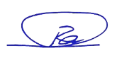
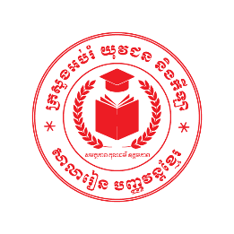
Total: 458 Students
ស៊ី សុវណ្ណារ៉ា
Prepared by Academic Team
July 15, 2026

Full-time Teachers (New Academic Year 2026-2027) Second Campus
No | Current Classes |  |  | New Classes for
 | Teacher's Name | Level | Sts | Teacher's Name | Level | Students
1 | Yorn Boran | K1 | 6 | N/A (New) | K1 | N/A
2 | Reth Vochnear | K2 | 11 | Yorn Boran (New) | K2 | 6
3 | Ra Sovannsopor | K3 | 7 | Reth Vochnear | K3 | 11
4 |  |  |  | Ra Sovannsopor | G1 | 7
Grand Total:


Total: 24 Students
ស៊ី សុវណ្ណារ៉ា
Prepared by Academic Team
July 15, 2026

